

**A Group Project Submitted for Undergraduate MA CIA-3 Lab**

**2024 -2025**

**By**

**HARDIK SHAH (2241131)**

**HIMANSHI AGARWAL (2241132)**

**SUMIT ROBERTS EMMANUEL (2241160)**

**Bachelor of Computer Applications**

**Under the supervision of**

**Dr. Manasa Kulkarni**

**SYNOPSIS**

**ABSTRACT**

SnapQuest is an innovative game that combines fun, creativity, and observation into a thrilling daily challenge. Players will be assigned a unique task each day at a random time. The moment the task is revealed, a 5-minute timer begins. The player aims to complete the task within this time frame by photographing a specific object.

For example, the task might be: "Take a photo of a blue car." The player must quickly locate the specified object, capture a photo, and upload it for verification. The quicker the player completes the task, the more points they earn. Points are deducted from their score if a player fails to complete the task within the allotted time.

At the end of each day, SnapQuest generates a leaderboard ranking the players with the highest points. This creates a competitive yet engaging environment, pushing players to observe their surroundings more closely and act swiftly.  
  
SnapQuest blends the joy of photography with the thrill of racing against time, offering a daily adventure that encourages exploration and creativity.

**INTRODUCTION**

SnapQuest is an exciting mobile game that combines creativity, observation, and speed. Each day, players receive a random photo task, such as "Take a picture of a red bicycle," with a 5-minute countdown starting as soon as the task is revealed. The challenge is to quickly locate and photograph the specified object before time runs out.

Points are awarded based on how fast players complete the task, with quicker submissions earning more points while failing to finish within the time limit results in deductions. A daily leaderboard ranks players by their performance, fostering a competitive environment and motivating players to improve.

SnapQuest transforms everyday surroundings into a playground for exploration and creativity, offering a unique blend of photography and time-based challenges. It’s a fun and fast-paced way to push users to observe their world more closely while enjoying a thrilling daily adventure.

**OBJECTIVES**

* **Enhance Creativity**: Players are encouraged to be creative in interpreting and capturing the task, especially when objects may be scarce or difficult to find.
* **Build Consistency**: Players are motivated to engage with the game daily to maintain or improve their leaderboard ranking, encouraging regular participation and consistency.
* **Strategic Planning**: Players must think strategically about where to find the specified objects in their environment and act quickly to capture them within the time limit.
* **Strengthen Time Management**: Players need to manage their time effectively within the 5-minute window to complete tasks, honing their time management skills under pressure.
* **Strategic Planning**: Players must think strategically about where to find the specified objects in their environment and act quickly to capture them within the time limit

**EXISTING SYSTEMS**

### **Snap Challenges (Snapchat):** Snapchat has various creative challenges where users are encouraged to submit themed photos. These challenges often rotate and include elements such as filters or AR lenses to make the experience more interactive.

### **Instagram's Hashtag Challenges:** Instagram users often participate in hashtag-based challenges (e.g., #30DayPhotoChallenge) where they are tasked with posting pictures based on a daily theme. Although not built into the app, it has become a user-driven trend.

### **52Frames:** 52Frames is a photography challenge platform that offers weekly assignments designed to help photographers practice and improve their skills. The challenges are curated with detailed themes and participants can upload their weekly photos for community feedback.

**PROPOSED SYSTEMS**

* **Daily Random Task Generation**: The system will generate a unique, random photo task for each player daily. The task will be specific to an object or scene that players must find and capture using their device's camera.
* **5-Minute Countdown Mechanism**: As soon as the task is revealed, a countdown timer will start, giving the player exactly 5 minutes to complete the challenge. The countdown is integrated into the user interface, constantly reminding the player of the remaining time.
* **Real-Time Scoring and Point System**: Points are awarded based on how quickly the player completes the task. Faster completion results in higher scores. Failure to complete the task within the 5-minute window results in point deductions, adding an element of urgency and challenge.
* **Daily Random Task Generation**: At the end of each day, the system will generate a daily leaderboard that ranks players based on the points they accumulated. Players can see how they rank against others, encouraging competition and motivating repeated engagement.

**DESIGN**

* **Data Flow Diagrams**

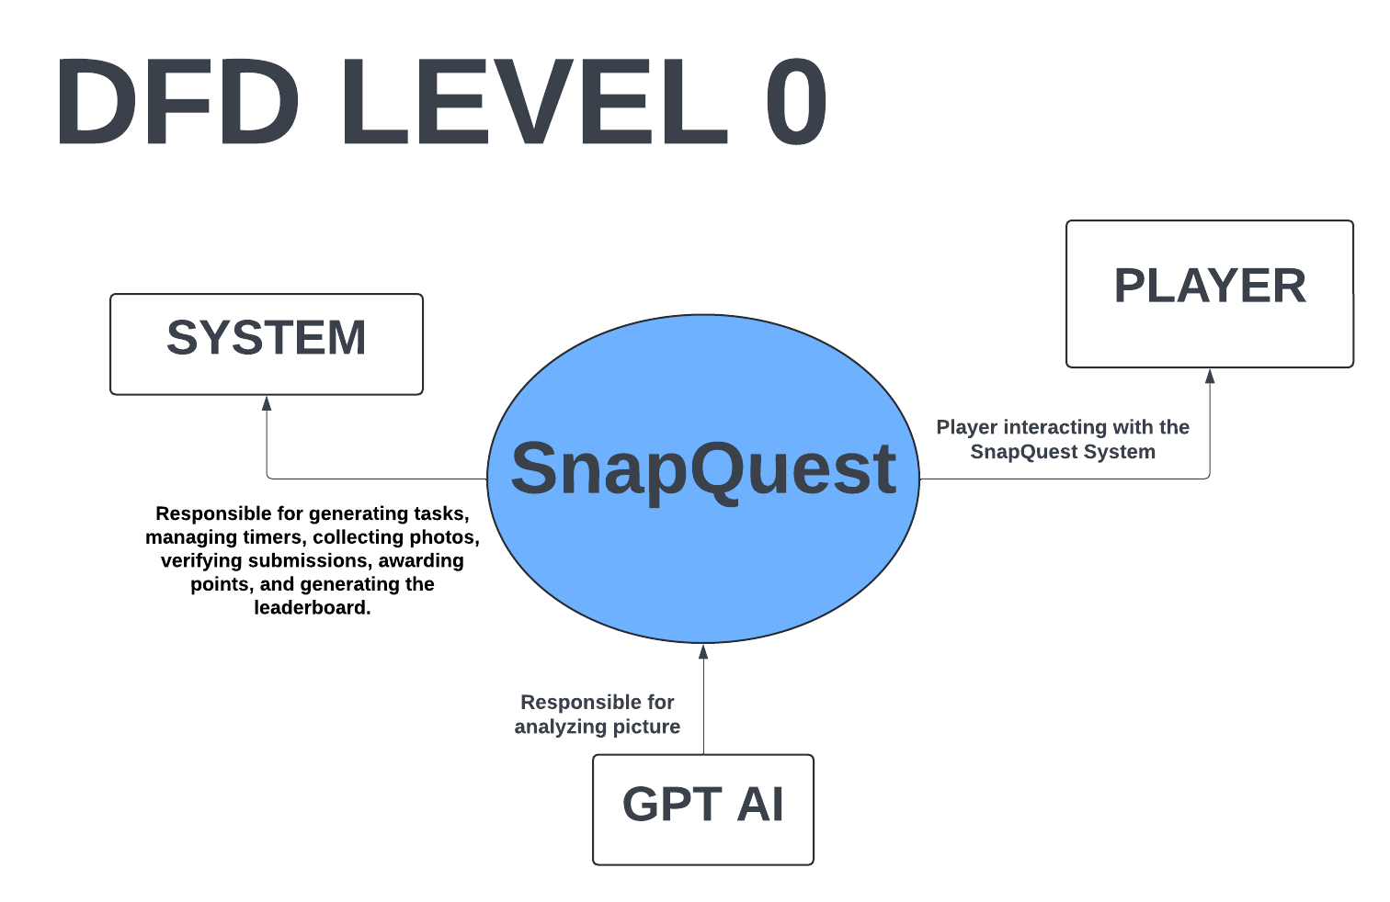

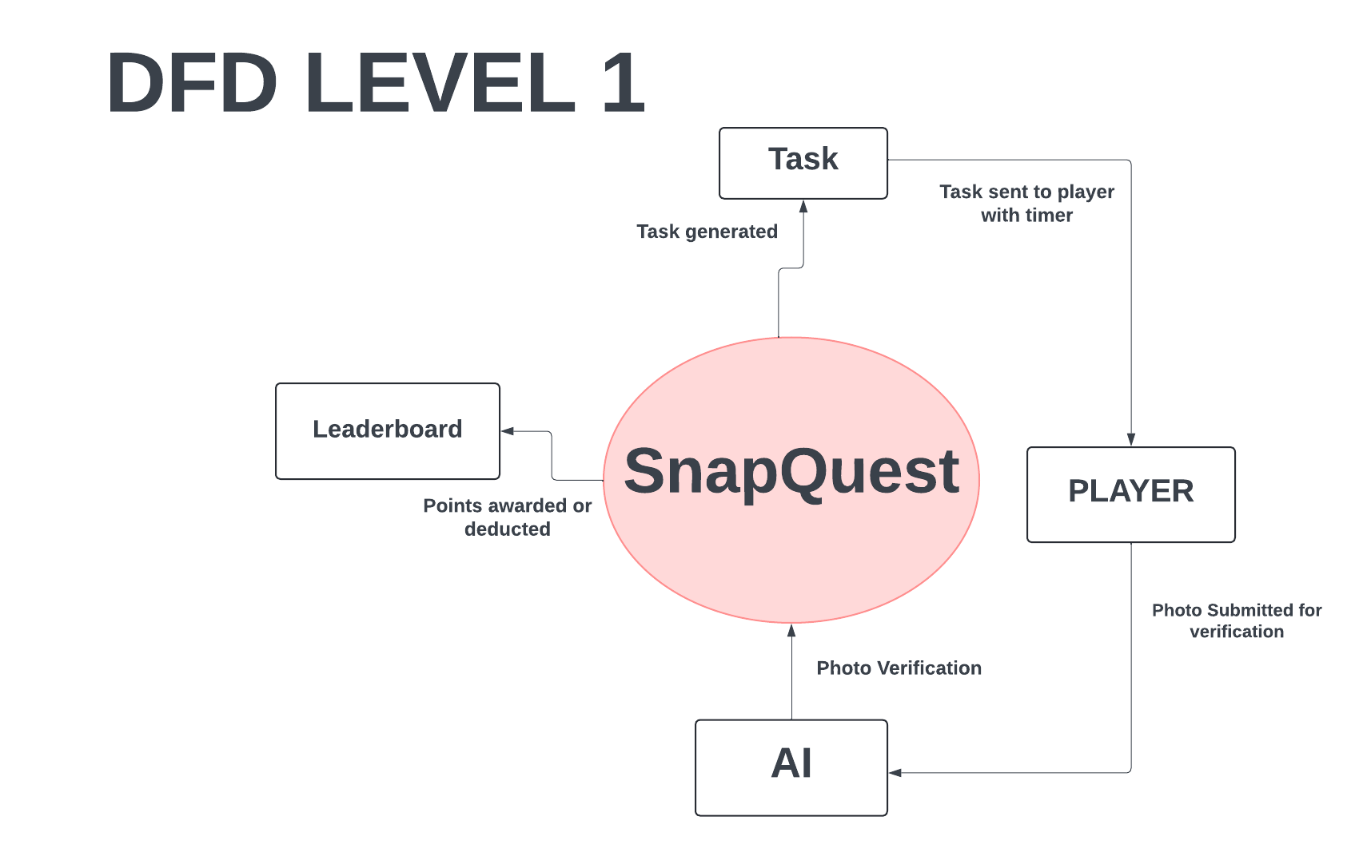

* **ER Diagram**

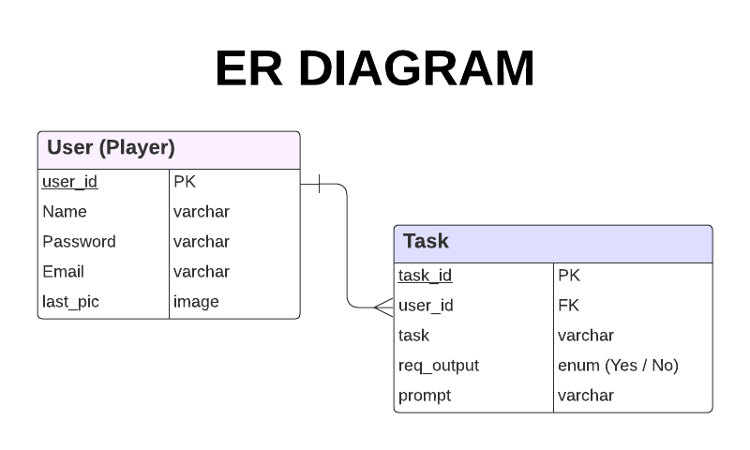

**METHODOLOGY**

* Kotlin for Front-End Development
* Kotlin and Java for Back End Development
* Firebase for Database Management
* AI model for Image Recognition

**CONCLUSION**

SnapQuest offers a dynamic and innovative experience that combines creativity, observation, and real-time competition. By generating unique, time-sensitive tasks daily, the game challenges players to act quickly and strategically to capture specific objects, fostering creativity and enhancing time management skills. Unlike existing systems like Snapchat Challenges, Instagram Hashtag Challenges, and 52Frames, SnapQuest introduces a 5-minute countdown and a competitive leaderboard, adding a sense of urgency and encouraging daily engagement. This structured approach makes SnapQuest an exciting and engaging platform for players seeking fun, exploration, and competition.